# On the Interdependency between Artificial Intelligence and THE Environment and its Implications on CS Education)

Marc Berges1 & Jonas Vollhardt2

1Friedrich-Alexander-Universität Erlangen-Nürnberg, Germany, marc.berges@fau.de

2Friedrich-Alexander-Universität Erlangen-Nürnberg, Germany

Focus Topics: AI and Data Science Curricula and Implementation in School, AI and Data Science Education for Social Good

## Introduction

The ongoing development of computing technology impacts society and increases the awareness of computer science. Industry and politics demand that students have computing literacy, and digitalization changes almost all fields of daily life. This development has increased with the introduction of generative artificial intelligence (AI) to society in general and education in particular. In education, two effects arise. On the one hand, education, and first and foremost computer science education, must address the need for computing literacy; on the other hand, digitalization changes the subject itself. So, both must react to the demands that result from the interdependency between AI and our environment.

Let us look at the current process of digitalization and AI-fication, which is already evident in countless digital artifacts in our environment. The “Dagstuhl Triangle” (Brinda & Diethelm, 2017) defines three perspectives on digital phenomena and artifacts. Initially, the idea of phenomena occurred in natural sciences and was transferred by Diethelm et al. (2012) to computer science education. Central to the idea is an observable event or object based on computer science. The outcome is the central aspect, while the CS system remains invisible or at least a black box. Moreover, the phenomenon happens in peoples’ everyday lives. However, to emphasize the artificial character of AI, we should talk about artifacts. Those are human-made and not nature-given. Furthermore, in most cases, we cannot understand an AI system through experiments, which contrasts phenomena (Lindner & Berges, 2024).

Regarding the massive impact of AI, we claim that computer science must take responsibility for the ongoing transformation processes. Changes to our environment through computer science artifacts must be well-considered and sustainable.

## Human Environment

To address this, we would like to initiate the following holistic view (including a broader understanding of the term environment):

In general, the human environment can be considered as a bundle of causal relations. It consists of at least three spheres of influence: ecosphere, sociosphere, and technosphere (Gardiner, 1989). Supplementary, the sociosphere might be separated into two sub-spheres: politics and social fabric. While politics addresses a group of people, the social fabric corresponds to individuals. Technosphere refers to the human-created or human-altered natural environment, so it lies across the other two spheres and contains one additional field: economy.

## Interdependency Between AI and the Environment

Generative AI (genAI) is a striking example of how CS has far-reaching effects on our environment, which then, in turn, impact computer science: Humans create genAI systems, which generate digital artifacts that become visible in the environment, for instance, in terms of AI-generated images. This enforces environmental changes in all areas. For example, increased risk of political influence through fake images (politics), increased CO2 emissions due to the high computing power required to generate images (ecology), social tensions and conflicts due to fake news (social fabric), faster and possibly personalized generated advertisements with fundamentally different paradigms (economy). This, in turn, impacts people in general (i.e., by having to question information even more critically, by having to deal with global warming, etc.) and CS (i.e., by emerging needs for better fake news detection, etc.). All in all, as proposed earlier by Schulte and Budde (2018), computing technology has significant backcoupling effects on humans 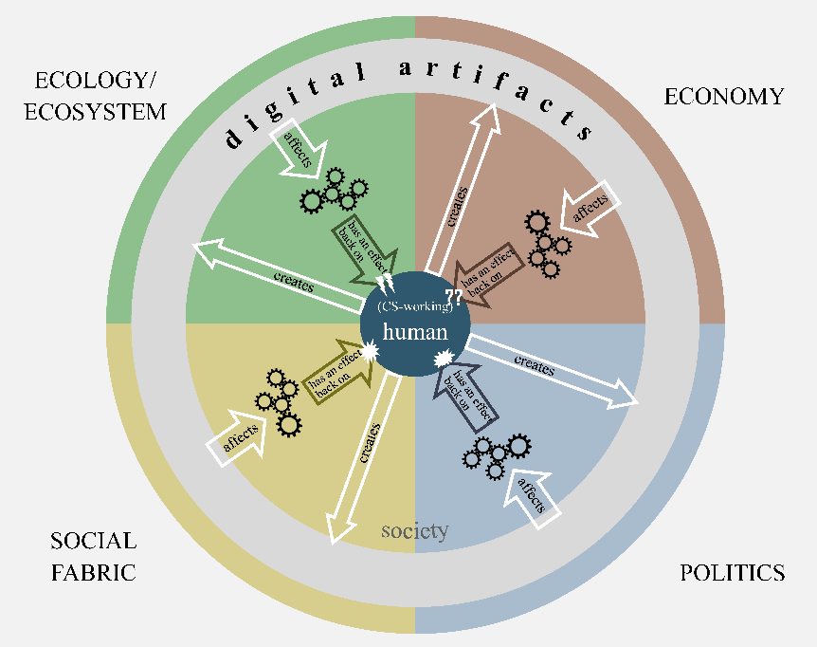and computer science.

Figure 1. Model of interdependencies between CS and environment

## Implications on CS Education

Computer science education must be aligned accordingly to responsibly and sustainably handle transformative technology like AI responsibly and sustainably. This implies at least the following objectives. Make society CS and AI literate, which includes teaching basic knowledge about AI to all, for example, and practicing the appropriate handling of digital systems and artifacts. The basic knowledge can be adapted from the framework of Long & Magerko (2020), for instance, but foremost, it is on the philosophy behind all those concepts. Understanding the change in perspective on digital artifacts and processes is necessary. As Tedre et al. (2021) described, a new way of computational thinking evolved from this change. Finally, there is a huge necessity to change the understanding of computer science education by only teaching technical or digital perspectives as proposed by the Dagstuhl triangle. Moreover, it is necessary to include the different interdependencies between AI and the environment. A huge opportunity arises in making AI a nucleus for subject-inclusive teaching (e.g., Xie et al., 2024). We have to discuss the formation of the environment through AI/CS artifacts in computer science education. In the end, this is nothing more than expanding the area of computer science and society to interdependencies between CS and environment relating to, for instance, sustainability (e.g., the energy needed for training AI models), impacts on democracies (e.g., algorithms on social media, biases in AI systems, post-factual information retrieval), new economic business models, or the impact of big data on society.

Second, re-think computer science teacher education. The described change in perspective and the interdependencies also affect teacher training. AI is not just another topic, like a more efficient search algorithm, that can be taught to children, where a small teacher training is enough. So, AI has to be integrated into the teacher training programs as an explicit part, and in-service teachers have to be taught to teach AI in special professional development programs, extending their knowledge beyond regular CS (Linder & Berges, 2024)

Last, train developers in decision-making regarding the sustainable development of transformative technologies: One must always consider the impact of a new feature beforehand. Limits of digitalization, in general, will also have to be discussed in this context. This discussion starts in secondary schools involving the developers starting tomorrow. So, to address all the needs of interdependencies between CS/AI and the environment, not only the possibilities of upcoming transformative technologies like AI have to be integrated into curricula, but also a discussion, respectively the needed underlying knowledge of what the society wants to be like in the future under the impact of these technologies.

## Conclusion

All in all, transformative technologies like AI cause the need to rethink the subject and its teaching. We plan to conduct further research on the interdependencies between computer science, AI, and the environment. With a more detailed understanding of these, we hope to address the needs and identify concrete and efficient approaches to teaching them after rebuilding curricula in computer science education.

## References

Brinda, T., & Diethelm, I. (2017). Education in the Digital Networked World. In A. Tatnall & M. Webb (Eds.), IFIP Advances in Information and Communication Technology: Vol. 515, Tomorrow's learning: Involving everyone: Learning with and about technologies and computing: 11th IFIP TC 3 World Conference on Computers in Education, WCCE 2017, Dublin, Ireland, July 3-6, 2017 : Revised selected papers (pp. 653–657). Springer.

Brundtland, G. H. (1987). Our common future. http://www.un-documents.net/ocf-ov.htm UN document A/42/427.

Diethelm, I., Hubwieser, P., & Klaus, R. (2012). Students, teachers and phenomena: Educational reconstruction for computer science education. In Proceedings of the 12th Koli Calling International Conference on Computing Education Research - Koli Calling '12. ACM Press. https://doi.org/10.1145/2401796.2401823.

Gardiner, W. L. (1989). Forecasting, planning and the future of the information society. In High technology workplaces: Integrating technology, management, and design for productive work environments, Goumain, P. (Ed.). Van Nostrand Reinhold, New York, 27–39.

Lindner, A., & Berges, M. (2024). Reconstruction of Transformative CS Topics in Education: A Model Proposal for Artificial Intelligence. Journal of Digital Life and Learning, 4(1), 25–42. <https://doi.org/10.51357/jdll.v4i1.274>.

Schulte, C., & Budde, L. (2018). A Framework for Computing Education. In M. Joy (Ed.), ACM Other conferences, Proceedings of the 18th Koli Calling International Conference on Computing Education Research (pp. 1–10). ACM. https://doi.org/10.1145/3279720.3279733

Tedre, M., Denning, P., & Toivonen, T. (2021). Ct 2.0. In O. Seppälä (Ed.), ACM Digital Library, 21st Koli Calling International Conference on Computing Education Research (pp. 1–8). Association for Computing Machinery. <https://doi.org/10.1145/3488042.3488053>

Xie, B., Sarin, P., Wolf, J., Garcia, R. C. C., Delaney, V., Sieh, I., Fuloria, A., Varuvel Dennison, D., Bywater, C., & Lee, V. R. (2024). Co-designing AI Education Curriculum with Cross-Disciplinary High School Teachers. Proceedings of the AAAI Conference on Artificial Intelligence, 38(21), 23146–23154. https://doi.org/10.1609/aaai.v38i21.30360