GENERATION AI: PEDAGOGICAL FRAMEWORKS
AND TOOLS FOR AI EDUCATION
Matti Tedre¹ & Henriikka Vartiainen²
¹School of Computing, University of Eastern Finland
²School of Applied Educational Science and Teacher Education, University of Eastern Finland
firstname.lastname@uef.fi

Focus Topics: Tools, Learning Materials

Educational Tools
AI education is different from classical CT, and it needs pedagogical approaches specifically tailored and contextualized for the purposes of AI (Tedre et al., 2021). This talk presents the pedagogical frameworks, classroom approaches, and learning material developed and refined through the implementation of four AI-driven tools to support data agency (Vartiainen et al., 2024b):
GenAI Teachable Machine: https://tm.gen-ai.fi/ (cross-curricular)
GenAI Somekone: https://somekone.gen-ai.fi/ (AI and media education)
GenAI Profiling Game: https://classroom.gen-ai.fi/ (AI and media education)
Teachable Robot: https://www.techrxiv.org/1253118 (craft and technology education)
Below we present to more detail two of these tools, GenAI TM and GenAI Somekone, and outline the pedagogical ideas that drove the development of the tools and classroom interventions.

GenAI Teachable Machine
The GenAI Teachable Machine (designed and developed by Nicolas Pope et al. (2024)) is a no-code mobile app studio that lets young learners to work with machine learning (ML) by creating their own ML-driven applications. This tool simplifies the complex processes of ML into a user-friendly environment. Students can train models using their own data, experiment with various AI actions, and deploy their creations as standalone mobile apps, fostering a hands-on understanding of supervised learning and AI workflows. Fig. 1 presents the workflow and concepts addressed at each step.
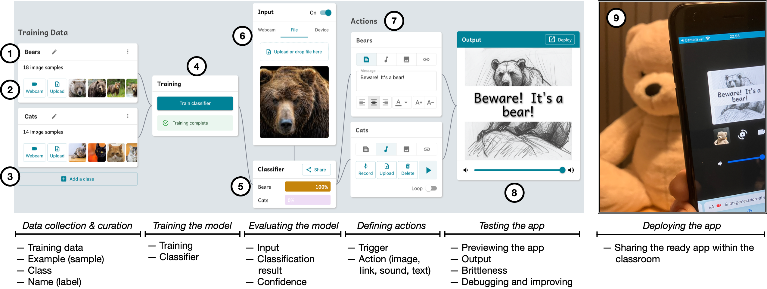
Figure 1: The GenAI Teachable Machine Workflow and Some Concepts Addressed
The first stages of the workflow are similar to Google’s popular TM2 (Pope et al., 2024): The user names each class ⓵, and populates it with images either dragging and dropping, uploading, using the webcam to capture images, connecting a mobile phone to capture images, or by adding any number of friends' devices to collaboratively add images ⓶. Data can be curated by moving images between classes or removing images ⓶. New classes can be added ⓷. The data collection and curation stage present four key concepts: training data, example, class, and name. After the data curation, user proceeds to train the classifier ⓸.
The tool interface conceptually separates the trained classifier ⓹ and the input mechanism ⓺. Google TM2's advanced options (like adjustment of epochs, batch size, and learning rate) are hidden for novice users, and also analytics, such as confusion matrix, accuracy, and loss per epoch, can only be accessed through an API.
Unlike other tools available, the users create a standalone app by connecting classifier results to actions (sound, text, image, link). Elements ⓻ to ⓽ are not found in the GTM2 or other existing tools. The user defines zero to four actions for each class ⓻. Those actions are triggered by the classifier result ⓹. Images can be uploaded or drag & dropped, and sounds can also be recorded in the tool ⓻. Users can test their live apps using the preview component ⓼, which dynamically shows the actions triggered by the classifier, enhancing children's understanding of the interrelations between the parts. The ready app is deployable in a new browser tab, and shareable to classmates' devices through a QR code ⓽. No data are stored or processed outside the classroom.

GenAI Somekone
Somekone (Pope et al., 2024b) immerses students in the realm of social media algorithms. Its Instagram-like interface is designed for exploring key AI concepts, including 1) data collection, 2) profiling, 3) engagement, and 4) content recommendation. In addition to individual views on students' devices, Somekone offers a teacher's view on the classroom projector, which can also illustrate 5) clustering through clustered and color-coded social networks, 6) co-engagement by showing networks of images liked by the same users, 7) topic affinity by grouping #hashtags liked by the same users, and 8) recommendation algorithms through heat maps that visualize how different recommendation algorithms impact what content a user is likely to be shown and what content the user is likely not shown. The tool is aimed at demystifying how social media platforms tailor user experiences, and it provides a platform for discussing the ethical and societal implications of AI technologies in classroom settings.
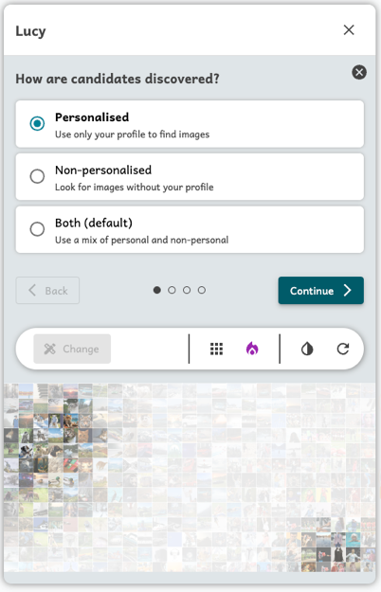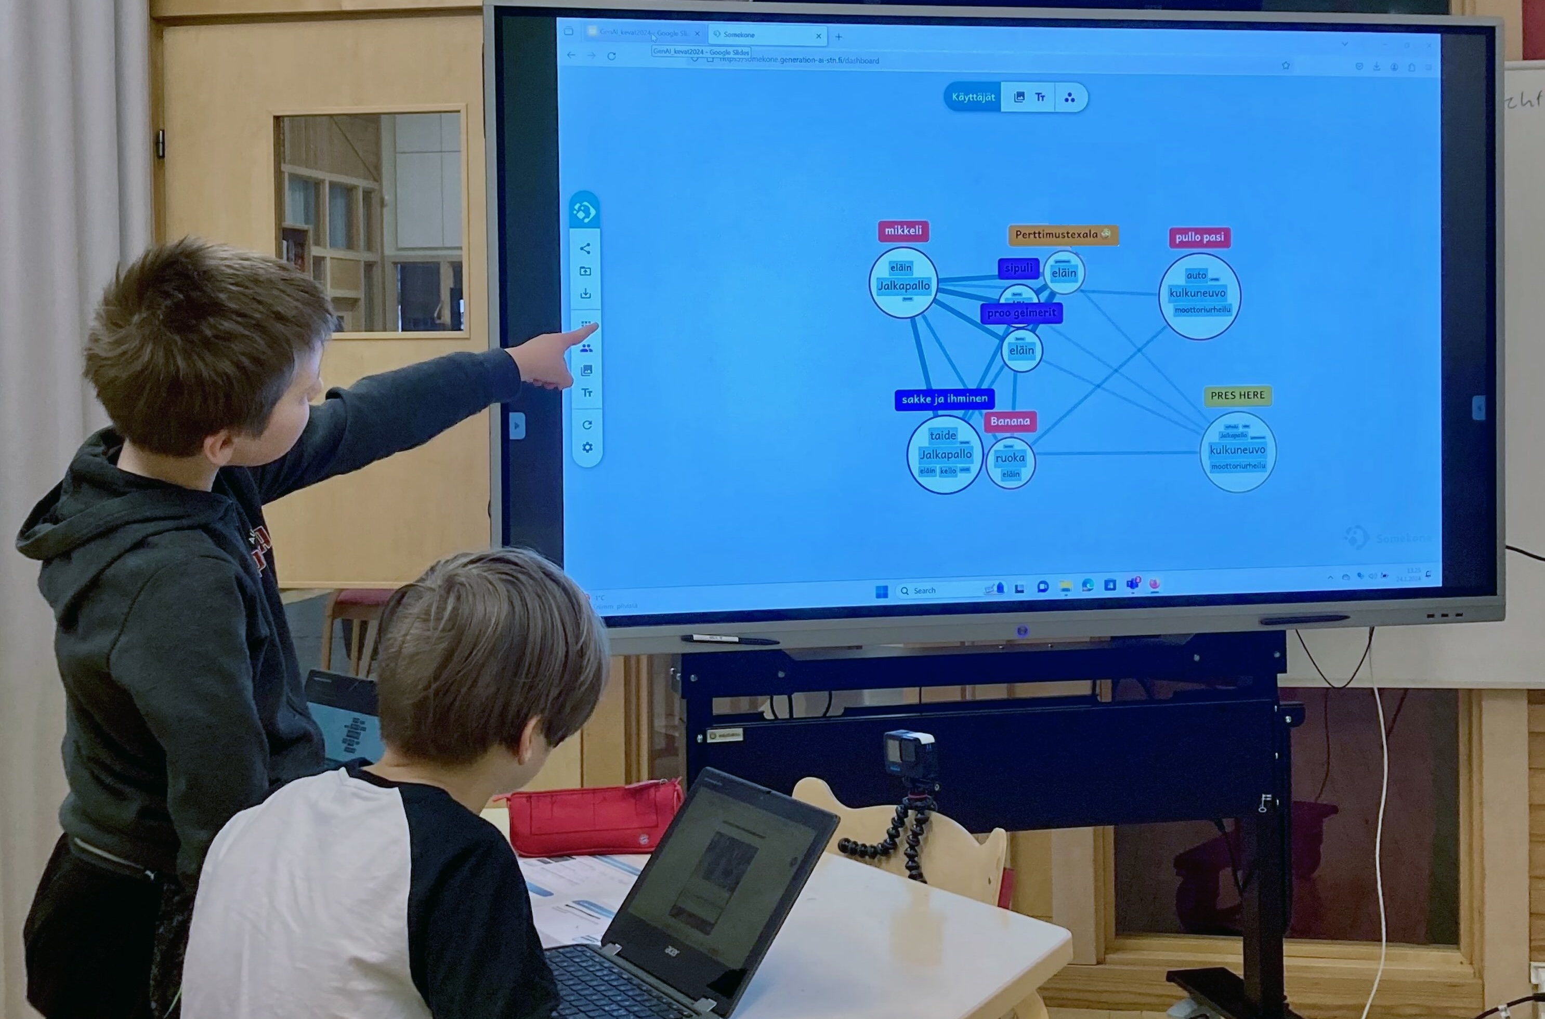
Figure 2: Somekone’s Instagram-style interface and some XAI and classroom views

Pedagogy of AI Education with Somekone and GenAI TM

Our experience with these tools underscores the importance of scaffolding students' conceptual understanding, agentive actions and ethical awareness by providing tools, materials, and tailored pedagogical models that altogether contextualize complex AI concepts and make them concrete, visible, and meaningful (Toivonen et al., 2020; Vartiainen et al., 2024; Lin et al., 2025; Vartiainen et al., 2021).
Grounded in design-oriented pedagogy, the GenAI Teachable Machine positions children as designers and knowledge creators. It scaffolds the development of conceptual understanding of machine learning processes and workflows by enabling them to train models in real-time and to make their own apps and creative projects (Kahila et al., 2024). In this way, new conceptual knowledge is linked to practical applications, grounded in students' ideas and interests.
The Somekone tool fosters collaborative learning and inquiry through hands-on experiences where children are guided to construct their conceptual understanding by testing their prior conceptions, conducting experiments, and explaining their conclusions with systematic evidence. By that way, it engages students in collaborative knowledge construction in which they can actively explore AI concepts, their operations, relations, and connections to everyday life.
The profiling game has shown a low-floor, almost unplugged approach to teaching AI-related data, profiling, and inference (Kahila et al., 2024b). Through a game-based activity, it encourages students to critically analyze how AI systems categorize and influence human behavior.
Together, such distributed scaffolding- provided through multiple affordances such as educational technology, curriculum materials, peer discussions, and teacher facilitation—is essential not only for cultivating conceptual understanding, but also for supporting critical thinking and curriculum discussions of AI ethics and AI’s societal impacts. By drawing on their own observations and shared understandings, students are empowered to collaboratively question data-driven practices and mechanisms, so that they can also envision and take informed actions toward alternative possibilities.

References

Kahila, J., Vartiainen, H., Tedre, M., Arkko, E., Lin, A., Pope, N., Jormanainen, I., and Valtonen, T. (2024). Pedagogical framework for cultivating children’s data agency and creative abilities in the age of AI. Informatics in Education, 23(2):323–360. https://doi.org/10.15388/infedu.2024.15
Kahila, J., Vartiainen, H., Arkko, E., Lin, A., Pope, N., and Tedre, M. (2024b). Enhancing understanding of data traces and profiling among K–9 students through interactive classroom game. In Proceedings of the 19th WiPSCE Conference on Primary and Secondary Computing Education Research, WiPSCE ’24. https://doi.org/10.1145/3677619.3677635
Lin, A., Salonen, A., Pope, N., Vartiainen, H., and Tedre, M. (2025). A versatile low-cost kit for teaching novice learners AI using robotics components and a no-code development playground. To appear in Proceedings of the Thirty-Eighth AAAI Conference on Artificial Intelligence, 2025. https://www.techrxiv.org/1253118
Pope, N., Vartiainen, H., Kahila, J., Laru, J., and Tedre, M. (2024). A no-code AI education tool for learning AI in K-12 by making machine learning-driven apps. In 2024 IEEE 24th International Conference on Advanced Learning Technologies (ICALT), pages 105–109. https://doi.org/10.1109/ICALT61570.2024.00037
Pope, N., Kahila, J., Vartiainen, H., Saqr, M., Lopez-Pernas, S., Roos, T., Laru, J., and Tedre, M. (2024b). An XAI social media platform for teaching K-12 students AI-driven profiling, clustering, and engagement-based recommending. To appear in Proceedings of the Thirty-Eighth AAAI Conference on Artificial Intelligence, 2025. https://doi.org/10.48550/arXiv.2412.13554
Pope, N., Kahila, J., Laru, J., Vartiainen, H., Roos, T., and Tedre, M. (2024). An educational tool for learning about social media tracking, profiling, and recommendation. In Proceedings of 2024 IEEE International Conference on Advanced Learning Technologies (ICALT), pages 110–112. https://doi.org/10.1109/ICALT61570.2024.00038
Tedre, M., Denning, P. J., and Toivonen, T. (2021). CT 2.0. In Proceedings of the 21st Koli Calling International Conference on Computing Education Research, Koli Calling ’21, New York, NY, USA. ACM. https://doi.org/10.1145/3488042.3488053
Toivonen, T., Jormanainen, I., Kahila, J., Tedre, M., Valtonen, T., and Vartiainen, H. (2020). Co-designing machine learning apps in K–12 with primary school children. In Proceedings of the 2020 IEEE 20th International Conference on Advanced Learning Technologies (ICALT), pages 308–310. https://doi.org/10.1109/ICALT49669.2020.00099
Vartiainen, H., Toivonen, T., Jormanainen, I., Kahila, J., Tedre, M., and Valtonen, T. (2021). Machine learning for middle schoolers: Learning through data-driven design. International Journal of Child-Computer Interaction, 29:100281. https://doi.org/10.1016/j.ijcci.2021.100281
Vartiainen, H., Kahila, J., Tedre, M., López-Pernas, S., and Pope, N. (2024). Enhancing children’s understanding of algorithmic biases in and with text-to-image generative AI. New Media & Society, page 14614448241252820. https://doi.org/10.1177/14614448241252820
Vartiainen, H., Pellas, L., Kahila, J., Valtonen, T., and Tedre, M. (2024b). Pre-service teachers’ insights on data agency. New Media & Society, 26(4):1871–1890. https://doi.org/10.1177/14614448221079626

