# Analysing artificial neural networks in high school mathematics education

Stephan Kindler1, Sarah Schönbrodt2 & Martin Frank1

1Karlsruhe Institute of Technology, Germany, [stephan.kindler@kit.edu](mailto:stephan.kindler@kit.edu)

2Paris Lodron University of Salzburg, Austria

Focus Topics: Learning materials

## Artificial intelligence education in mathematics education

The rapid development of artificial intelligence (AI) and its integration into everyday life presents new challenges within the educational system. It is essential, that students possess a comprehensive understanding of the functionality of this technology to use the potential responsibly (Touretzky et al., 2022). The development of what is known as AI literacy (Long & Magerko, 2021) is therefore becoming the responsibility of the entire school system, rather than just computer science (Micheuz, 2020) or higher education. Mathematics, in particular, provides the tools to look deeper into the inner workings of AI models. Indeed, several AI methods, including support vector machines, decision trees and the k-nearest neighbour algorithm, offer a variety of connections to the content of school mathematics, including vector calculus, statistics and differential calculus (Schönbrodt et al., 2022; Biehler & Fleischer, 2021; Hazzan & Mike, 2022). In this regard, AI education represents an authentic and modern application of school mathematics.

## Research goal and related work

Our research provides a didactic analysis of artificial neural networks (ANNs) as a learning object in school mathematics. Given their widespread use, they represent an authentic and relevant learning object that also offers the opportunity to address a range of mathematical concepts from the school curriculum – from analysis. In our research, we develop, implement and analyze possible learning paths and compare their effectiveness to enable students to reach the intended learning goals.

Several approaches exist to teach ANNs in schools, but they mostly focus on computer science education (e.g. Heinemann et al., 2020; Martins & Gresse Von Wangenheim, 2023). Studies from a data science perspective showed that students are able to understand ANNs, including their performance and the impact of training parameters (Santana et al., 2018; Estevez et al., 2019). Most of the approaches reduced the complexity of the ANN models. They focused more on the data science workflow and less on the mathematical aspects themselves, most often not mentioning non-linear activation functions or the mathematics of the optimisation algorithm. One approach that greatly reduces the complexity is the simulation of Boolean functions for an age-appropriate introduction to ANNs in middle school (e.g. Touretzky et al., 2024).

Our previously developed application-oriented learning path for upper secondary education (Kindler et al., 2023) uses a life expectancy prediction task based on a real data set to introduce ANNs. Students begin with a linear regression and investigate an optimization algorithm which determines model parameters. This provides a foundation for understanding and developing ANNs as non-linear models with similar optimization algorithms, thus enabling a transfer of concepts.

Our new intended learning path starts with an examination of the elementary ANN building blocks. Students start by using classical mathematical techniques to analyse the nodes of an ANN as mathematical functions. The composition of which forms the overall network; thus, students should comprehend the impact of the chosen functions and parameters. This can allow them to assess the predictive capabilities and extrapolation limits of simple and complex ANNs.

## Design principles of learning material for the intended learning path

In accordance with the design-based research methodology (Prediger et al., 2015), the development of our learning and teaching materials is guided by several key design principles. Firstly, the role of mathematics in understanding ANNs is emphasized, thereby highlighting the relevance of mathematics. We highlight both intra- and extra-mathematical interdisciplinary connections. We use a digital learning environment to enable authentic work with ANNs and to enable the use of interactive elements, such as an automated feedback system and scaffolded tips to accommodate heterogeneous learning groups.

Incorporating many of these principles is the *Use-Modify-Create* cycle (Lytle, 2019), which we apply to AI models. Here, students are first introduced to fundamental concepts by using and analysing a pre-existing model. They then proceed to modify this model before constructing their own AI model. This methodology enables a transition from a guided introduction to an open construction of models, thereby promoting a deeper understanding and fostering creativity.

## Insight into the intended learning path

In order to implement and examine the intended learning path in the mathematics classroom, we have developed teaching and learning material for use with upper secondary school students. It is intended to be used as either a one-day workshop or as a series of individual lessons. Students work with interactive digital learning materials that allow scaffolding of the learning content.

Following an introductory overview of AI, the students are presented with a basic feed-forward network (Figure 1). Given the simplicity of the network, it can be formulated as a composition of several elementary mathematical functions. For example, each node () in the second layer of the network with incoming values can be regarded as a function with .

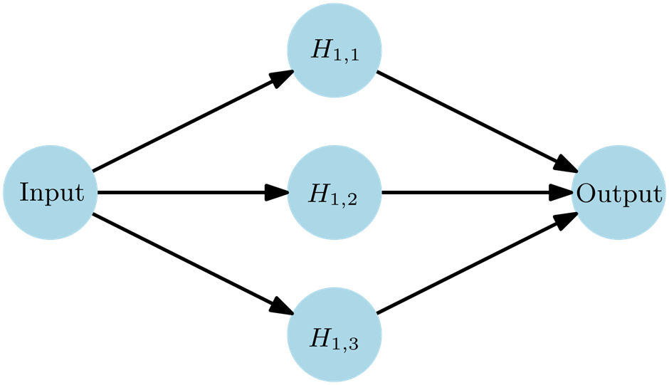

**Figure 1: Simple neural network with one hidden layer**

In the majority of cases, this is a concatenation of the linear function with and a non-linear activation function , for example, the sigmoid function with . Upper secondary school students can carry out a function analysis of both the function and the concatenated functions and should be able to make statements about the domain and codomain of the function and the global trends of the corresponding graphs. Moreover, students can identify the influence of the parameters and on the graph of as stretching in the -direction and shifting in the -direction.

The output node of the simple network is a linear combination of the preceding three nodes. It is important for students to understand that the output is the weighted sum of the functions previously analysed. Thus, the network is a one-dimensional function which can be visualised as a two-dimensional graph. An analysis of the functions of the nodes should enable students to predict the course of this graph and allow them to describe the impact of each parameter on the output and graph of the ANN.

Next, the students are presented with a network whose parameters were selected for the ANN to locally approximate the sine curve. This function is typically introduced in middle school (Figure 2). Students should be able to apply their previous knowledge to describe the ability of this network’s ability to approximate the sine curve. That is, that the network can only approximate the curve locally. They can then verify their assumptions using interactive digital tools.

Ein Bild, das Diagramm, Reihe, Text enthält.

**Figure 2: Approximating the sine curve with a simple ANN**

This should enable students to express ideas for a more suitable network for this task and have an informed discussion about the inherent limitations of even larger ANNs, e.g. the ability to generalise.

## Outlook

The didactic analysis and the developed learning path aim at demystifying ANNs by providing students with tools to understand their functionality through classical mathematical analysis. The presented learning path will be subject to further didactic investigation. Based on the described teaching and learning material, we will conduct and evaluate design experiments with students and revise the material according to our findings. Future design experiments will evaluate students' ability to follow the learning path and will compare its effectiveness with our previous linear regression-based approach.

## References

Biehler, R. & Fleischer, Y. (2021). Introducing students to machine learning with decision trees using CODAP and Jupyter Notebooks. *Teaching Statistics*, 43, 133–142.

http://doi.org/10.1111/test.12279

Estevez, J., Garate, G., & Graña, M. (2019). Gentle introduction to artificial intelligence for high-school students using scratch. *IEEE access*, *7*, 179027-179036.

https://doi.org/10.1109/ACCESS.2019.2956136

Heinemann, B., Budde, L., Schulte, C., Biehler, R., Frischemeier, D., Podworny, S., & Wassong, T. (2018). Data Science and Big Data in Upper Secondary Schools: What Should Be Discussed From a Perspective of Computer Science Education? *Archives of Data Science*, Series A, 5(1), 1–18. <https://doi.org/10.5445/KSP/1000087327/26>

Hornik, K.; Stinchcombe, M. & White, H. (January 1989). Multilayer feedforward networks are universal approximators. *Neural Networks*. 2 (5): 359–366.

https://doi.org/10.1016/0893-6080(89)90020-8

Kindler, S.; Schönbrodt, S., Frank, M. (2023). From school mathematics to artificial neural networks: Developing a mathematical model to predict life expectancy. *In Proceedings of the Thirteenth Congress of the European Society for Research in Mathematics Education (CERME13)*. Alfréd Rényi Institute of Mathematics and ERME.

Lytle, N., Cateté, V., Boulden, D., Dong, Y., Houchins, J., Milliken, A., ... & Barnes, T. (2019, July). Use, modify, create: Comparing computational thinking lesson progressions for stem classes. In *Proceedings of the 2019 ACM Conference on Innovation and Technology in Computer Science Education* (pp. 395-401). https://doi.org/10.1145/3304221.3319786

Long, D. & Magerko, B. (2020). What is AI literacy? Competencies and design considerations. In *Proceedings of the 2020 CHI conference on human factors in computing systems*, 1-16. <https://doi.org/10.1145/3313831.3376727>

Martins, R. M., & Gresse Von Wangenheim, C. (2023). Findings on teaching machine learning in high school: A ten-year systematic literature review. *Informatics in Education*, 22(3), 421-440.

http://doi.org/10.15388/infedu.2023.18

Micheuz, P. (2020). Approaches to Artificial Intelligence as a Subject in School Education. In Brinda, T., Passey, D., Keane, T. (Hrsg.) Empowering Teaching for Digital Equity and Agency. *Springer*. <https://doi.org/10.1007/978-3-030-59847-1_1>

Prediger, S., Gravemeijer, K. & Confrey, J. Design research with a focus on learning processes: an overview on achievements and challenges. *ZDM Mathematics Education* **47**, 877–891 (2015). https://doi.org/10.1007/s11858-015-0722-3

Santana, O. A., de Sousa, B. A., do Monte, S. R. S., de Freitas Lima, M. L., & e Silva, C. F. (2020, April). Deep learning practice for high school student engagement in STEM careers. *In 2020 IEEE Global Engineering Education Conference (EDUCON)*.164-169.

https://doi.org/10.1109/EDUCON45650.2020.9125281

Schönbrodt, S., Camminady, T. & Frank, M. (2022). Mathematische Grundlagen der Künstlichen Intelligenz im Schulunterricht. *Mathematische Semesterberichte,* 69, 73–101. <https://doi.org/10.1007/s00591-021-00310-x>

Touretzky, D., Gardner-McCune, C. & Seehorn, D. (2022). Machine learning and the five big ideas in AI. *International Journal of Artificial Intelligence in Education*, 1-34.

https://doi.org/10.1007/s40593-022-00314-1

Touretzky, D. S., Chen, A., & Pawar, N. (2024). Neural Networks in Middle School. *ACM Inroads*, 15(3), 24-28. <https://doi.org/10.1145/3677610>