# Fostering data and ai competencies in primary schools

Anja Gärtig-Daugs1 & Ute Schmid2

1University of Bamberg, Germany, [anja.gaertig-daugs@uni-bamberg.de](mailto:anja.gaertig-daugs@uni-bamberg.de)

2University of Bamberg, Germany

Focus Topics: AI and data science curricula and implementation in schools, learning materials

## Relevance of Data and AI competencies in primary schools

Data-driven tools and applications of Artificial Intelligence (AI) determine our everyday life and thus are present in the daily lives of young children (Feierabend et al., 2023). In Germany, one central objective of education policy is to support children in exploring, understanding and shaping the digital world through appropriate educational programs (KMK 2016; KMK 2021). In this context, it is important to promote an understanding of basic Data Science and AI principles (Schmid et al., 2021). Children should know how AI systems function and that data build a crucial basis for the training of AI technologies. They should be aware that the data they disclose about themselves by interacting with search engines, intelligent voice assistants or large language models can be used to draw conclusions about the individual users. They should also be aware that data can be employed to improve AI systems or in the worst case to manipulate users. Therefore, we argue that the conceptual basics of data literacy and AI should be integrated in primary school lessons.

Previous research has shown that key data literacy concepts can be didactically reduced and conveyed in a way that is suitable for primary school children. Wolff et al. (2016) for example taught children aged 9 to 10 years how to analyze, interpret and reflect the data of intelligent electricity meters. One prerequisite, that primary school children can acquire forerunner skills on their way from mere users to responsible questioners of data and AI is that teachers provide appropriate learning opportunities. In spite of the recommendation of the German Informatics Society (2023), data and AI competencies are so far not a compulsory component of (university) teacher training. Therefore, many teachers lack data and AI competencies (Lindner & Berges, 2023; Vo & Pancratz, 2023) that would be the prerequisite for methodological and didactic approaches to forster data and AI competencies among students.

## Professionalisation of primary school teachers for fostering Data and AI competencies through a Massive Open Online Course (MOOC)

### Theoretical conception of the course

Data literacy encompasses the areas of knowing and understanding data and data sources, collecting data, managing data, evaluating data, applying data, and critically reflecting the handling of data (Heidrich, 2018; Grillenberger & Romeike, 2018; Ludwig & Thiemann, 2020; Ridsdale et al., 2015). Data skills constitute the basis for the understanding of AI systems and their underlying databases (Schmid, 2025). Therefore, they are an integral part of AI literacy. AI literacy refers to the ability to know and understand, responsibly deal with and critically reflect on AI concepts, technologies, applications, and their implications on the individual, society and environment (Ng et al, 2021; Schmid, 2025). Relevant topics for AI education in primary schools can be derived from the Five Big Ideas of AI (Touretzki, Gardener-McCune & Seehorn, 2019): perception, representation and reasoning, machine learning, natural interaction, and reflecting the positive and negative societal impact of AI technologies. Teachers can convey these ideas from primary school onwards. This spiral-curricula approach allows for initial experiences and explanatory approaches and enables students to experience the complexity of systems step by step (Diethelm, 2021).

From a didactic point of view, computer science education in primary schools should relate to concrete experiences of children (GI, 2018). Learning situations should be designed in such a way that they enable children to learn about the functioning principles and underlying theoretical concepts. Furthermore, they should provide concrete user experiences with analogue playing materials or digital applications. Finally, they should stimulate to reflect on the effects on the individual and on society as a whole (Brinda et al., 2016; GI, 2018; Diethelm, 2021; Schmid et al., 2021)

Based on the theoretical considerations mentioned above, we developed a massive open online-course to qualify primary school teachers for integrating data and AI topics in primary school lessons. The course either can be integrated in a blended-learning format in university courses or can be self-paced followed by professional teachers. According to the findings from Lindner & Berges (2023) and Vo & Pancratz (2023), no prior knowledge for following the course is required. With regard to relevant teacher competencies for teaching in a digitalized world (Schultz-Pernice et al., 2017), the course aims at forstering technical and didactic competencies in the field of Data Science and AI and empowers teachers to plan, conduct, evaluate and share lessons that deal with data and AI topics.

### Structure of the course

The course is structured in five modules. The first module “Data, Information and Knowledge” provides the conceptual framework for the following modules. It clarifies basic terms such as data, information, and knowledge. It deals with different types of data, the analysis and visualization of data. In order to illustrate the theoretical concepts and to allow teachers to use the examples in class, the course uses fictional data from the children`s world such as fact sheets about students as well as real world data from official statistics, for example about pets.

The second module “Data Storage and Data Access” introduces the concept of digital representation of different data types such as numerical, text and image data and comprises a discussion of the advantages and disadvantages of digital data storage.

Module three “Learning from Data” deals with the possibilities and limitations of learning from data using machine learning methods. It discusses the special features of learning algorithms that are trained on large data sets. As exemplary machine learning methods, the perceptron for the binary classification of objects and the functioning of a Chabot that can simulate human conversation are illustrated. The module provides two interactive exercises that allow the training of a perceptron and a Chatbot.

The fourth module “Reliability of Data” deals with different types of errors and biases, discusses social problems associated with distorted data and gives strategies for checking the plausibility of information.

Finally, module five “Data Protection and Data Security” deals with the difference between data protection and data security, sensitizes for the (economic) interest behind collecting data and introduces basic principles for the creation of secure passwords and the encryption of data.

### Design of the course

The course promotes a wide range of educational methods and forms of presentation to promote participants engagement. An ongoing story about two children, their aunt who is a computer scientists and a robot serves as storytelling framework for the course: Each module starts with a short comic style video or (animated) picture in which the protagonists of the story motivate the topic that is covered by every single module (see Figure 1). These different parts of the story shall motivate teachers to follow the course, but can also be used as an introduction to the topic in class.

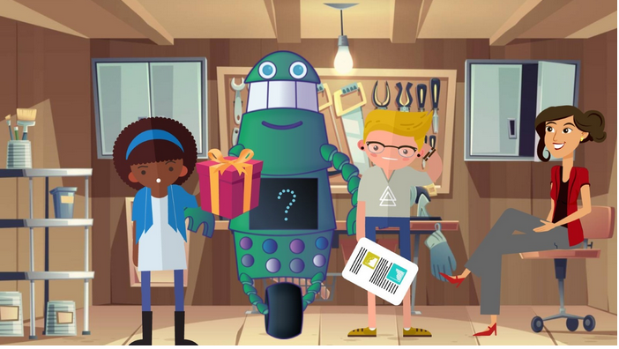

Figure 1: Illustration of the storytelling framework of the course with the protagonists Alice, robot DaLiK, Bob and aunt Christina (from left to right, screenshot from <https://moodle.ki-campus.org/mod/page/view.php?id=5261>, as of 15/12/2024)

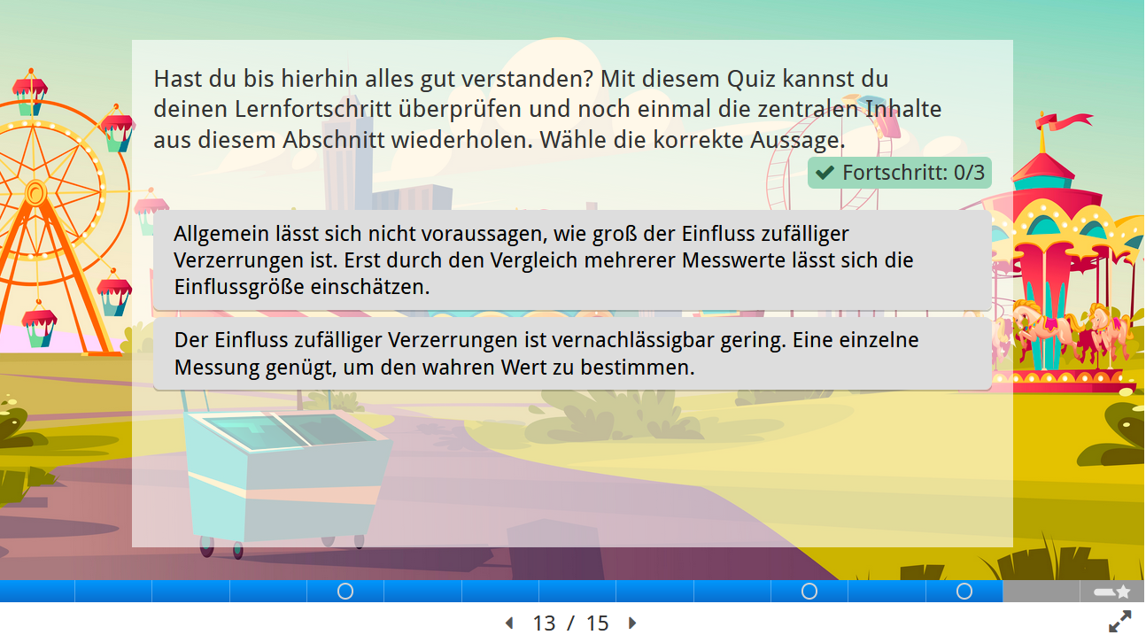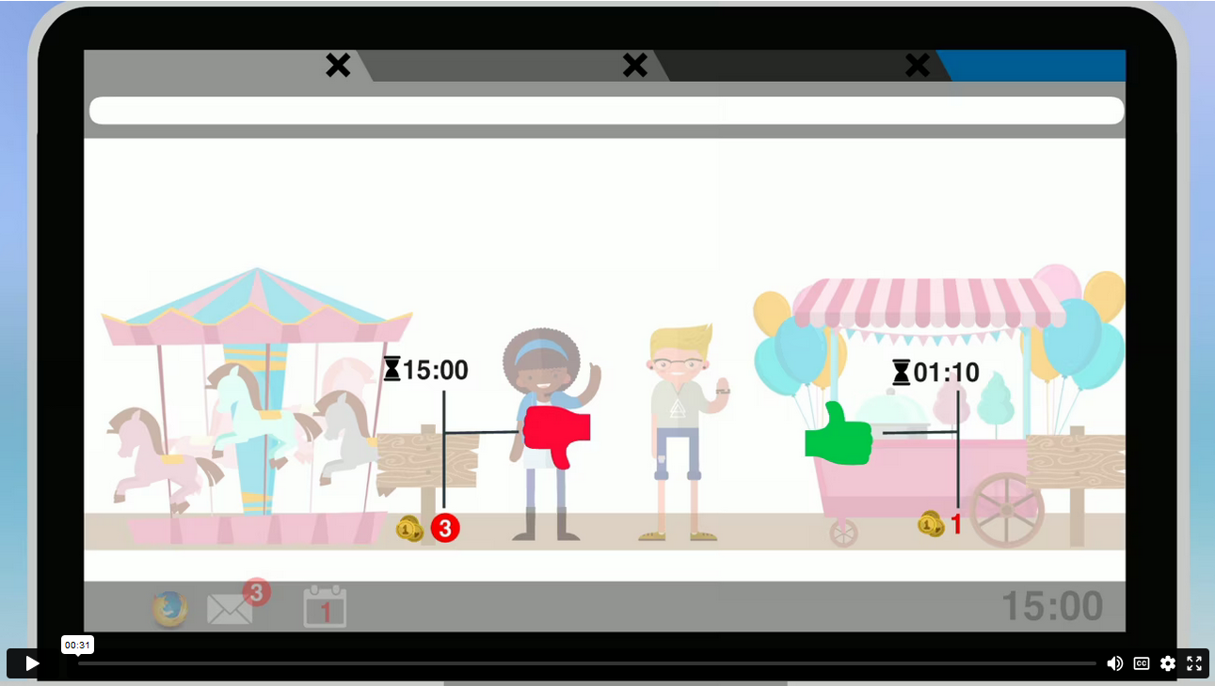In order to support self-regulated learning, the course comprises explanatory short videos (see Figure 2, left), info texts, interactive presentations and quizzes (see Figure 2, right) for self-evaluation based on H5P (HTML5 Package; H5P Group, 2024).

Figure 2: left: video for the explanation of the term “knowledge” (screenshot from <https://moodle.ki-campus.org/mod/videotime/view.php?id=5253>, state: 15/12/2024), left: interactive H5P-presentation with integrated quiz for the topic “bias” (<https://moodle.ki-campus.org/mod/h5pactivity/view.php?id=5639>, as of 15/12/2024)

In addition, exemplary teaching and learning materials and gaming activities are provided at the end of each module that allow for the integration of the topics into school lessons. The materials and games are designed so that data and AI literacy can be promoted in different contexts and subjects such as Maths, Language, Science or Arts. This illustrates the interdisciplinary relevance and potential of data and AI competencies. All materials provided are published under the CC-BY-license so that they can be adapted by teachers according to the needs and interests of their class and shared again.

In our talk, we will give insights in the teaching and learning materials (see Figure 3) that deals with the perceptron learning algorithm and is made for learning in teams of two. The materials convey how computers can learn and make predictions for new objects from existing data. The objective of the game is to deduce the rule regarding which package contains a coin by using example packages. In the example shown, each training package with dotted wrapping paper contains a coin. The first line illustrates the preparation of the game: one student hides the coins in all packages with dots. The second line marks the packages with an arrow that the other student may open in order to find out the rule.

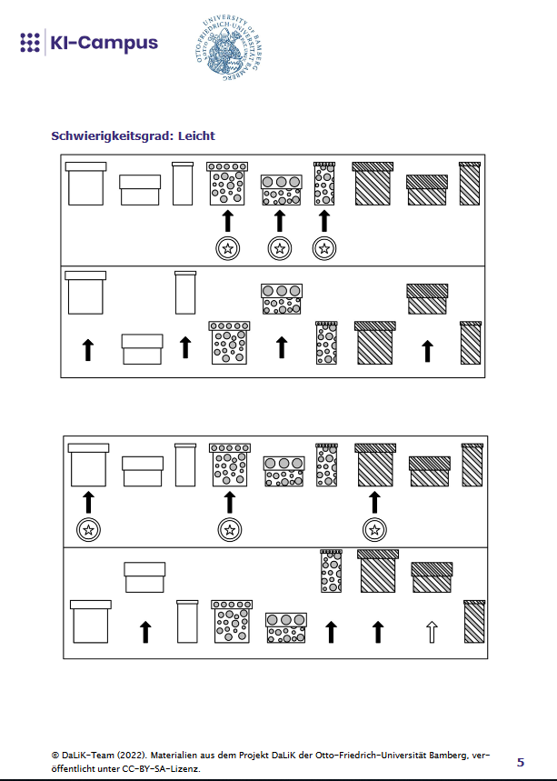

Figure 3: Coin search: insight into the learning material for the topic machine learning (AI campus course “Data literacy for Primary Schools, as of 15/12/2024)

**References**

Brinda, T., Diethelm, I., Gemulla, R., Romeike, R., Schöning, J., & Schulte, C. (2016, December 15). *Dagstuhl-Erklärung: Bildung in der digital vernetzten Welt.* <https://dagstuhl.gi.de/fileadmin/GI/Hauptseite/Aktuelles/Projekte/Dagstuhl/Dagstuhl-Erklaerung_2016-03-23.pdf>

Diethelm, I. (2021, June 15). *Künstliche Intelligenz und Informatik.* <https://digid.jff.de/ki-expertisen/ki-informatik/>

Feierabend, S., Rathgeb, T., Kheredmand, H., & Glöckler, S. (2023). *KIM-Studie 2022. Kindheit, Internet, Medien. Basisuntersuchung zum Medienumgang 6- bis 13-Jähriger*. Medienpädagogischer Forschungsverbund Südwest.

GI/Gesellschaft für Informatik (2018, July 9)*. Kompetenzen für informatische Bildung im Primarbereich.*<http://ddi.uni-wuppertal.de/website/repoLinks/v63_Kompetenzen_Entwurfsfassung_2018-06-26.pdf>

GI/Gesellschaft für Informatik (2023, November 29). *Informatikkompetenzen für alle Lehrkräfte*. <https://dl.gi.de/server/api/core/bitstreams/e271f87d-1087-4617-83f5-b0ef98984b04/content>

Grillenberger, A., & Romeike, R. (2018). Data Literacy und das Modell der Schüsselkonzepte des Datenmanagements. In Gesellschaft für Informatik (Ed.), *Data Literacy und Data Science Education: Digitale Kompetenzen in der Hochschulausbildung* (pp. 10–13).

Heidenreich, J. (2018). Grundlegende Digitale Kompetenzen in der Hochschulausbildung. In Gesellschaft für Informatik (Ed.), *Data Literacy und Data Science Education: Digitale Kompetenzen in der Hochschulausbildung* (pp. 6–9).

H5P Group (2024). *H5P* [HTML5 content]. <https://h5p.org/>

KMK/Ständige Konferenz der Kultusminister der Länder in der Bundesrepublik Deutschland (2016). *Bildung in der digitalen Welt. Strategie der Kultusministerkonferenz.* Ständige Konferenz der Kultusminister der Länder in der Bundesrepublik Deutschland.

KMK/Ständige Konferenz der Kultusminister der Länder in der Bundesrepublik Deutschland (2021). *Lehren und Lernen in der digitalen Welt. Die ergänzende Empfehlung zur Strategie „Bildung in der digitalen Welt“.* Ständige Konferenz der Kultusminister der Länder in der Bundesrepublik Deutschland.

Lindner, A., & Berges, M. (2020): Can you explain AI to me? Teachers’ pre-concepts about Artificial Intelligence. 2020 IEEE Frontiers in Education Conference (FIE), 1–9. <https://doi.org/10.1109/FIE44824.2020.9274136>

Ludwig, T., & Thiemann, H. (2020). Datenkompetenz – Data Literacy. *Informatik Spektrum, 43*(6), 436–439. <https://doi.org/10.1007/s00287-020-01320-0>

Ng, D.T.K., Leung, J.K.L., Chu, K.W.S., & Qiao, M.S. (2021), AI Literacy: Definition, Teaching, Evaluation and Ethical Issues. *Proceedings of the Association for Information Science and Technology, 58*, 504–509. <https://doi.org/10.1002/pra2.487>

Ridsdale, C., Rothwell, J., Smit, M., Bliemel, M., Irvine, D., Kelley, D., Matwin, S., Wuetherick, B., & Ali-Hassan, H. (2015). *Strategies and Best Practices for Data Literacy Education Knowledge.* Stifterverband.

Schmid, U. (2025). Grundkompetenzen im Bereich Künstliche Intelligenz (AI Literacy). In G. Brägger & H.-G. Rolff (Ed.), *Handbuch: Lernen mit digitalen Medien* (in print). Beltz.

Schmid, U., Gärtig-Daugs, A., Müller, L., & Werner, A. (2021). Grundkonzepte des Maschinellen Lernens für die Grundschule – Algorithmen, Biases, Generalisierungsfehler. *INFORMATIK 2021*, *Lecture Notes in Informatics,* 1611–1621. <https://doi.org/10.18420/informatik2021-135>

Schultz-Pernice, F., von Kotzebue, L., Franke, U., Ascherl, C., Hirner, C., Neuhaus, B., Ballis, A., Hauck-Thum, U., Aufleger, M., Romeike, R., Frederking, V., Krommer, A., Haider, M., Schworm, S., Kuhbandner, C., & Fischer, F. (2017): Forschungsgruppe Lehrerbildung Digitaler Campus Bayern: Kernkompetenzen von Lehrkräften für das Unterrichten in einer digitalisierten Welt. *merz – medien + erziehung, Zeitschrift für Medienpädagogik, 4,* 65–74. <https://doi.org/10.21240/merz/2017.4.16>

Touretzky, D., Gardner-McCune, C., Martin, F., & Seehorn, D. (2019). Envisioning AI for K-12: What Should Every Child Know about AI? *Proceedings of the AAAI Conference on Artificial Intelligence, 33*, 9795–9799. <https://doi.org/10.1609/aaai.v33i01.33019795>

Vo, G. M., & Pancratz, N. (2023): Vorstellungen von Lehramtsstudierenden zu künstlicher Intelligenz. In L. Hellmig & M. Hennecke (Ed.), *INFOS 2023 – Informatikunterricht zwischen Aktualität und Zeitlosigkeit* (pp. 73–82). Gesellschaft für Informatik.

Wolff, A., Montaner, J. J. C., & Kortuem, G. (2016). Urban Data in the primary classroom: Bringing data literacy to the UK curriculum. *The Journal of Community Informatics, 12*(3), 57–82. <https://doi.org/10.15353/joci.v12i3.3278>