# ai INTERACTION COMPETENCies: feedback literacy and Legitimation Code Theory Semantics

Jane Waite1

1Raspberry Pi Computing Education Research Centre, University of Cambridge, England, jane.waite@raspberrypi.org

AI and Data Science Competencies

## AI Interaction Competencies

Attempts are being made to define the competencies needed to be “AI literate”, each with a different and sometimes conflicting view (e.g. Long and Magerko, 2020; Touretzky et al., 2019). Irrespective of what view is taken, it is certain that users will need to interact in some way with AI applications. We suggest that AI interaction competency is one set of competencies within AI literacy that students must develop. There has been the suggestion that users will “shepherd AI systems” that have “agency but no intelligence” (Floridi, 2023). In “shepherding” such applications, research on hybrid interaction systems between humans and systems suggests that both the person and the technical product will influence each other (Schulte and Budde, 2018).

A key aspect of AI interaction that we suggest is that the person in the interaction should know about the different types of output or feedback that the AI system may produce, and what role the person should therefore take to most effectively use this feedback. A set of general education theories on feedback literacy provides a starting point to develop curriculum materials for teaching and researching this aspect of AI interaction competency. A second aspect of interaction is the structure of explanations produced by AI systems, and how the person in the interaction can review the quality and effectiveness of the explanation, to either prompt the system for a better-quality explanation or temper their use of it. The Semantic dimension of Legitimation Code Theory (LCT), a framework for analysing any sociological interaction, is a mechanism that can be used for this explanation review.

We contend that AI interaction competencies are particularly important in addressing equity issues, as some students may have pre-existing implicit “AI interaction capital” which will give them an advantage, exacerbating the digital divide. We suggest that AI interaction needs to be made visible to students, with vocabulary for them and their teachers to use, and teaching and learning activities provided so that all students can be made aware of and improve their AI interaction competencies.

## Feedback Literacy

### Feedback literacy includes three conceptual frameworks: student feedback literacy, teacher feedback literacy and feedback types. Student feedback literacy includes four interrelated student capabilities and dispositions required to help students understand and use feedback: i) appreciating feedback processes; ii) making judgements; iii) taking action; and iv) managing affect (Carless and Boud, 2018). Teacher feedback literacy concerns three dimensions: 1) teachers' design of feedback learning materials for students; 2) teachers' relational support helping students through emotional sensitivity, empathy and trust; 3) teachers' pragmatic decision-making, where they make compromises to manage feedback practices (Carless and Winstone, 2023). Feedback has been categorised into four types, each with different roles and processes for students to follow: a) Telling, a uni-directional transmission of ‘correct’ answers, students assuming a passive role; b) Guiding, where students are being pointed in the right direction so that they may learn by applying knowledge to practice; c) Developing understanding, creating meaningful abstractions, requiring students to be active in their construction or adjustment of knowledge structures; d) Opening up a different perspective, where students must be actively engaged in interpreting and evaluating knowledge (McLean et al., 2015).

In AI interaction systems, feedback is produced by the system, therefore, students should consider what feedback type has been produced. Is the output telling, guiding, knowledge-building or opening up? If the feedback is telling, will the student become over-reliant on the answers provided? How can we support students to consider their knowledge building, rather than completing the task? Students making judgements about AI output should be helped to consider how accurate the feedback is and how in line with their learning progression. Students will need to learn how they should act upon the output. Teachers in their review of large language model (LLM) augmented IDE program error messages for middle school learners asked for the output to guide rather than tell and that they and their students needed professional development and learning resources about feedback literacy to help them better use such interactions (Cucuiat and Waite, 2024).

**Legitimation Code Theory Semantics**

As well as teaching students about the type of AI-produced feedback and their role in using it, we can help students analyse AI explanations in that feedback and become better at using it and potentially improving it (through prompting) for more effective dialogue. We suggest we can do this by teaching students about semantic waves. Maton has proposed a conceptual toolkit called Legitimation Code Theory (LCT) that can be used to analyse sociological interactions (Maton, 2013).

Semantics, one dimension of LCT, analyses two concepts, semantic gravity and semantic density. Semantic gravity analyses how meaning relates to its context. Semantic gravity can be stronger or weaker, along a continuum. For example, if an explanation is a generalised, abstract definition, then semantic gravity is weaker than if the explanation was situated in a specific context. Semantic density relates to the complexity of meaning. If an explanation has a condensed meaning, say with technical complex terms, then semantic density is stronger than if everyday language was used with fewer contained meanings. These strengths can be drawn on a ‘semantic profile’ (e.g. Figure 1) where the y-axis shows semantic gravity and semantic density, and the x-axis represents time (Maton, 2013). A flat-line profile indicates the strengths stay the same over time, while other profiles can represent ‘semantic waves’, with strengths that move up and down. For example, Figure 1 shows the profiles of two students' essays. A low-achieving student's essay has been analysed to show a low flat-line profile, whereas the high-achieving student's essay has waves or recurrent moves down and up, indicating better explanations (Maton, 2013, p19). Moves reflect how complex meanings are built up or broken down and how examples are abstracted or abstractions made concrete (Maton, 2013).

*Figure 1: Example semantic profiles of two students' essays (Maton, 2013, p19).*

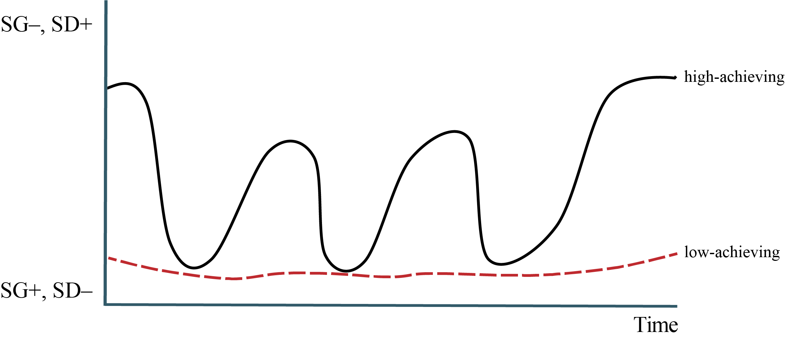

## Students and teachers can be taught about semantic profiling so that they can review explanations created by themselves and by others (Hartnett L, 2020; Sigsgaard, 2024; van Heerden, 2021). Concerning AI-produced explanations and whether these wave or can be manipulated to have certain semantic profiles, there is limited research (Senoamadi and Langsford, 2024). Similarly, whether students can use prompt engineering to change the profile of explanations needs investigation. However, we suggest that this is an important area of research that could have a far-reaching impact on the quality of dialogue between humans and AI agents and on the knowledge-building that can result from this. Perhaps prompt engineering may only be needed by students in the short term until the output from AI tools becomes more sophisticated in terms of feedback type tailored to student needs and profiled in the most useful way for a student.

## Next Steps

We call for discussion to explore what, how and whether we should teach feedback literacy and LCT semantics to students to improve their AI interaction competencies and to research the effectiveness of this on student use of AI. Similarly, we should consider teacher professional development and the training of system and resource designers so that the AI interaction eco-system can be reviewed and improved through teaching and training of the humans in the “loop” on feedback literacy and LCT semantics (Figure 2).

*Figure 2: The AI interaction ecosystem, showing AI interaction competency opportunities from teaching feedback literacy and LCT semantics to the humans in the “loop”.*

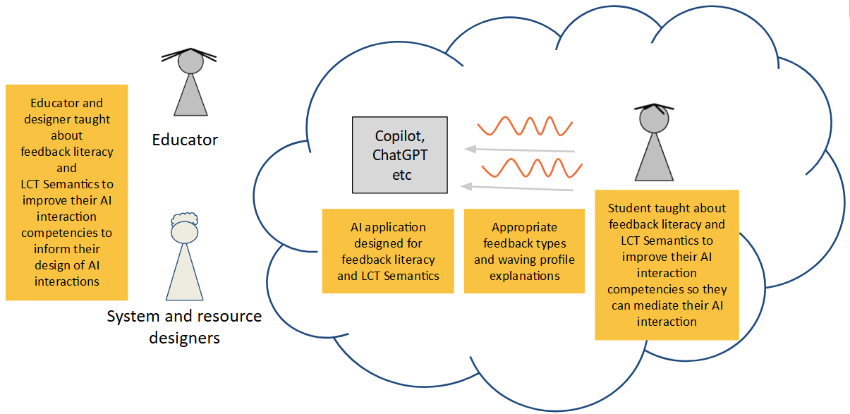

We suggest it is vital from an equity perspective that we explore improving student AI literacy through increasing AI interaction competencies via feedback literacy and LCT semantics to ensure that all students can make the best use of AI tools not only as they learn but also as they become discerning and critical consumers of AI technology.

## References

Carless, D. and Boud, D. (2018). The development of student feedback literacy: enabling uptake of feedback. Assessment & Evaluation in Higher Education, 43(8):1315–1325.

Carless, D. and Winstone, N. (2023). Teacher feedback literacy and its interplay with student feedback literacy. Teaching in Higher Education, 28(1):150–163.

Cucuiat, V. and Waite, J. (2024). Feedback literacy: Holistic analysis of secondary educators’ views of LLM explanations of program error messages. In Proceedings of the 2024 on Innovation and Technology in Computer Science Education V. 1, ITiCSE 2024, page 192–198, New York, NY, USA. Association for Computing Machinery.

Floridi, L. (2023). AI as Agency Without Intelligence: on ChatGPT, Large Language Models, and Other Generative Models. Philosophy & Technology, 36(1):15.

Hartnett L, M. M. (2020). Using the semantic wave to support intellectual disability nursing students to apply theory and evidence in practice. Learning Disability Practice.

Long, D. and Magerko, B. (2020). What is AI Literacy? Competencies and Design Considerations. In Proceedings of the 2020 CHI Conference on Human Factors in Computing Systems, pages 1–16, Honolulu HI USA. ACM.

Maton, K. (2013). Making semantic waves: A key to cumulative knowledge-building. Linguistics and Education, 24(1):8–22.

McLean, A. J., Bond, C. H., and Nicholson, H. D. (2015). An anatomy of feedback: a phenomenographic investigation of undergraduate students’ conceptions of feedback. Studies in Higher Education, 40(5):921–932.

Schulte, C. and Budde, L. (2018). A Framework for Computing Education: Hybrid Interaction System: The need for a bigger picture in computing education. In Proceedings of the 18th Koli Calling International Conference on Computing Education Research, pages 1–10, Koli Finland. ACM.

Senoamadi, T. and Langsford, D. (2024). Automating an analysis for semantic density: Using ai to code data. In Fifth International Legitimation Code Theory Conference, 2024, Johannesburg, South Africa. Wits School of Education, University of The Witwatersrand Johannesburg, South Africa.

Sigsgaard, A.-V. M. (2024). Semantic waves for helping teachers teach science to second language students. In Fifth International Legitimation Code Theory Conference, 2024, Johannesburg, South Africa. Wits School of Education, University of The Witwatersrand Johannesburg, South Africa.

Touretzky, D., Gardner-McCune, C., Martin, F., and Seehorn, D. (2019). Envisioning AI for K-12: What Should Every Child Know about AI? Proceedings of the AAAI Conference on Artificial Intelligence, 33(01):9795–9799.

van Heerden, M. (2021). (how) do written comments feed-forward? a translation device for developing tutors’ feedback-giving literacy. Innovations in Education and Teaching International, 58(5):555–564.