Refactoring Computer Science AND Data Science Education in the Age of Generative AI

Orit Hazzan
Technion – Israel Institute of Technology, Israel, oritha@ed.technion.ac.il

Focus Topics: Computer science education, GenAI

Introduction
In my presentation, I explore the opportunities that generative AI (GenAI) presents for computer science (CS) and data science (DS) education. I argue that GenAI not only retains the need for CS and DS education, but further, that by eliminating the need to deal with the technical details of programming and data analysis at some stages of the learning process, GenAI actually enables us to increase the level of abstraction and complexity of the tasks that we assign students and of the skills and competencies that we seek to impart.
Specifically, GenAI enables educators to teach essential skills like critical and innovative thinking, AI literacy, and ethical technology use, transforming traditional teaching paradigms into a more learner-centered pedagogy whose exact format cannot be currently predicted nor envisioned. As for the students, by integrating GenAI tools into their learning processes, learners can develop advanced competencies in creative problem solving, adaptive thinking, and collaborative intelligence that transcend traditional disciplinary boundaries. Moreover, GenAI provides unprecedented opportunities to personalize learning experiences, allowing students to explore complex concepts through interactive AI-assisted methodologies that foster curiosity, meta-cognitive skills, and computational thinking (Erez, Mike & Hazzan, 2024).
To illustrate the horizons that GenAI opens for CS and DS education, I revisit relevant pedagogical and cognitive models and theories and explore their implementation in the GenAI era, in the context of CS and DS education. These theories are categorized into three groups: pedagogy, learning, and content/competences:
- Pedagogy
  - Blum’s taxonomy (Bloom et al., 1956)
  - Assessment
  - Personalization/diversity/equity
  - Didactic transposition (Chevallard, 1985)
- Learning
  - Constructivism (Ben-Ari, 1998; Papert, 1980)
  - Cognitive load (Sweller & Chandler, 1991)
  - Motivation (Deci & Ryan, 2000; Ryan & Deci, 2017)
- Content / Competencies
  - Knowledge, skills, attitudes (KSA) model
  - Computational thinking (Wing, 2006)
  - Metacognition

Illustrations
In this section, I illustrate several of the above-listed theories and models through the teaching of AI concepts. Since AI has only relatively recently been incorporated into the high school computer science curriculum, it is only reasonable to ask a GenAI tool for help teaching it. Accordingly, my presentation is based on the working assumption that GenAI help can improve the teaching process of DS and AI, eventually leading to learners’ improved understanding.
GenAI can indeed be a powerful tool for preparing teaching materials on complex AI concepts, like backpropagation, making them more accessible to high school students. Following are several examples of how GenAI can assist in creating educational content for backpropagation. I recommend that the readership of this paper experiment with these suggestions.

1. Simplified explanations: GenAI can generate clear and concise explanations of backpropagation, breaking down the complex algorithm into more digestible pieces for high school students, thus reducing the cognitive load (Sweller & Chandler, 1991).
2. Visual aids: GenAI can create concept maps for teachers to guide the teaching process as well as diagrams and illustrations for students to visually represent the forward and backward passes in neural networks, helping students grasp the concept more easily. Figure 1 shows suggestions given by two GenAI tools. Even if not all details are applicable, it is clear that teachers can use these maps as an initial step in the creation of their teaching material. Furthermore, they can compare the two maps and formulate their own maps according to their class characteristics, level of mathematics, and prior computer science knowledge.
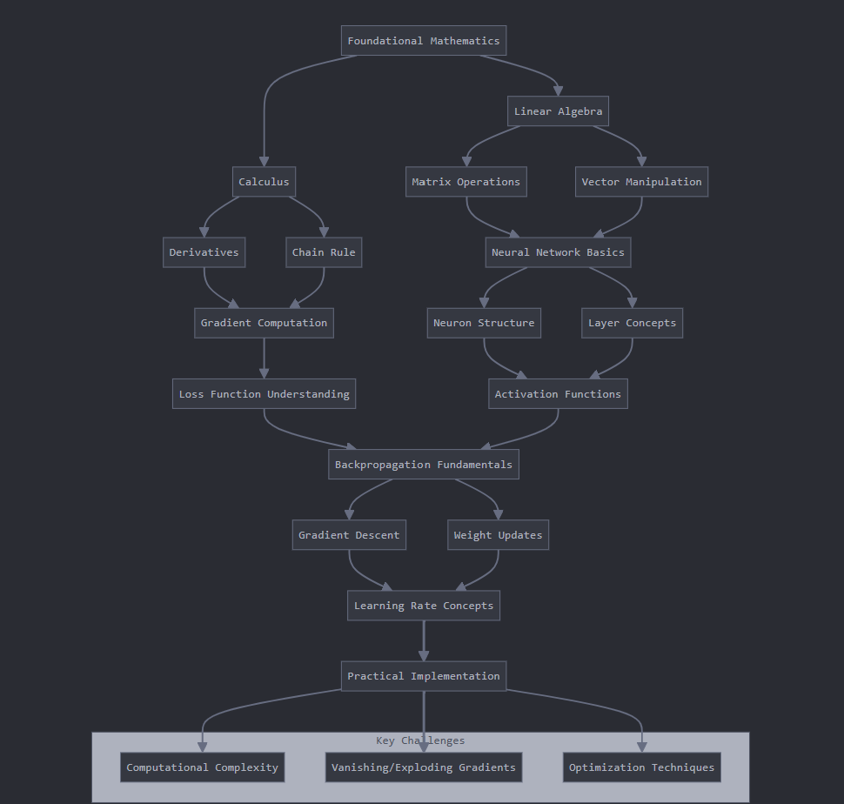 | 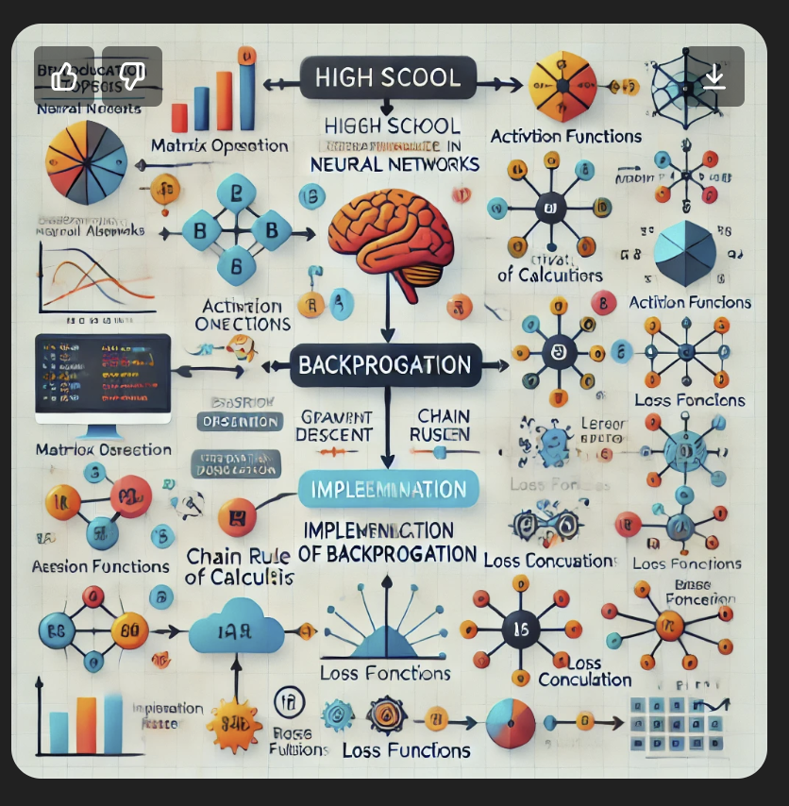
Figure 1: Concepts maps for teaching backpropagation (left – Claude; right – ChatGPT) (Prompt: Can you draw a concept map that can guide high school computer science teachers through the sequence of topics needed for backpropagation?)
3. Practical examples: GenAI can generate relatable examples and analogies to help students understand the relevance of backpropagation in everyday AI applications.
4. Step-by-step tutorials: GenAI can create detailed step-by-step guides on the implementation of backpropagation that are suitable for high school level.
5. Quiz generation: GenAI can produce quizzes and practice problems to test students' understanding of backpropagation concepts.
6. Customized learning paths: GenAI can help create personalized learning materials that adapt to individual students' progress and understanding of backpropagation.

In my presentation, I will delve into greater detail, as follows:
- With respect to pedagogy, I will focus on Bloom’s taxonomy and didactic transposition (Chevallard, 1985), which refers to the transformation of expert knowledge into teachable knowledge, that is, adapting complex or specialized content so that it can be transmitted effectively to students. I will demonstrate how GenAI can help educators deductively transpose a complex machine learning concept (such as backpropagation) into teachable material for any level or age group.
- With respect to learning, I will examine the theory of cognitive load (Sweller & Chandler, 1991) and illustrate how learning processes that are accompanied by GenAI tools can manage intrinsic cognitive load more effectively, reduce extraneous cognitive load, and promote germane cognitive load, which is the cognitive load that leads to meaningful learning processes. In the case of computer science education, this can be illustrated by students’ attempts to develop a computer program. The student has a 24/7 tutor that responds to his or her specific prompts (thus, reducing extraneous cognitive load); the LLM fixes small bugs and helps with syntax issues (providing support managing the intrinsic cognitive load), and promotes germane cognitive load by allowing the student to focus on the algorithmic aspect of the computer program development process. For example, if a student programs a machine learning algorithm, his or her focus can be placed on the algorithmic aspect of the algorithm, rather than on the syntax.
- With respect to content/competencies, such as computational thinking (Wing, 2006) and metacognitive skills, I will argue that these skills not only increase in importance, but that as the use of GenAI becomes more and more widespread, computational thinking and metacognitive skills will become an even more essential skill for all. Specifically, in the GenAI era, computational thinking is manifesting in a new form, namely prompt engineering, which all GenAI users are required to master (Erez, Mike & Hazzan, submitted).

Summary
One important takeaway from this presentation is that the CS and DS education community should perceive GenAI not as a threat, but rather as an opportunity to achieve pedagogical objectives and transmit the values that we have always sought to impart, but could not, due to the need to deal with the many technical details involved in programming and data analysis. In the presentation, this assertion will be highlighted from the perceptive of well-known theories and models, and from pedagogical, cognitive, and curricular perspectives.
Although my essay focuses on DS and AI learning, I believe that GenAI can be viewed as a pedagogical tool that all teachers can use for a variety of purposes, as illustrated above, from lesson planning, to actual teaching, to assessment, both on the class level and on the individual level. As such, it clearly has the potential to improve learning processes, which in turn can either use GenAI tools, or not.

References
Ben-Ari, M. (1998). Constructivism in Computer Science Education. SIGCSE Bull. 30(1), 257–261. https://doi.org/10.1145/274790.274308
Bloom, B. S., Engelhart, M. D., Furst, E. J., Hill, W. H., Krathwohl, D. R. (1956). Taxonomy of Educational Objectives: The Classification of Educational Goals. Vol. Handbook I: Cognitive Domain. New York: David McKay Company.
Chevallard, Y. (1985). La Transposition Didactique. Du Savoir Savant au Savoir Enseigné, 2nd edn 1991, La Pensée sauvage.
Deci, E. L., & Ryan, R. M. (2000). The “What” and “Why” of Goal Pursuits: Human Needs and the Self-Determination of Behavior. Psychological Inquiry, 11(4), 227–268. https://doi.org/10.1207/S15327965PLI1104_01
Erez, Y., Mike K. & Hazzan, O. (2024). Leveraging Computational Thinking in the Era of Generative AI, Blog@CACM, Communications of the ACM.
Papert, S. (1980). Mindstorms. Children, Computers and Powerful Ideas. New York: Basic books.
Ryan, R. M., & Deci, E. L. (2017). Self-determination theory: Basic psychological needs in motivation, development, and wellness. Guilford publications.
Sweller, J., & Chandler, P. (1991). Evidence for Cognitive Load Theory. Cognition and Instruction 8(4), 351–362. https://doi.org/10.1207/s1532690xci0804_5
Wing, J.M. (2006). Computational thinking. Communication of the ACM 49(3), 33–35.

